AN ANALYSIS OF THE SO2 CAP AND TRADE MARKETABLE PERMIT SCHEME: ARE HOT SPOTS A CONCERN?

by

Carl Mackensen, Lead Author

and

Team

May 2016

SIPA U6501 Quantitative Analysis II for International & Public Affairs

# Table of Contents

**I Abstract**

**II Introduction**

**III Literature Review**

**IV Data and Methods**

**V Results and Discussion**

**VI Conclusion**

**VII Bibliography**

**VIII Appendix**

1. **Abstract**

The objective of this project is to analyze the marketable permit scheme for sulfur dioxide emissions. Specifically, I will look at how this program has worked at the national and state levels. I examine the national level through a fixed-effects model. I then go on to look at whether Cap and Trade has resulted in the development of hotspots within specific states. As SO2 is a regional pollutant, and no geographic or temporal restrictions were put in place at the start of the program, SO2 emission hot spots could well be a concern. My data are directly from EPA and EIA, and are comprised of several merged datasets. They are panel data for 48 states and regions of the United States, from years 1980, 1985, 1990, and 1995 to 2013. My primary dependent variable was SO2 emissions, and the remainder of my variables were additional explanatory variables. My analysis took the form of running a number of regressions so that I could find out which/how many states experienced an increase in SO2 levels. Particularly, stage 1 of the program (1995 to 1999) and stage 2 of the program (2000 to 2013) were compared to the base period of stage 0 (1980, 1985, 1990). My fixed effects model found that emissions decreased significantly for stages 1 and 2 at the national level. I also found, through running 48 individual regressions, that at the state- level, while for the most part states experienced a significant drop in SO2 emissions, during stage 1 of the program relative to the period before the program (stage 0), there were a number of states which experienced significant increases in the pollutant at stage 1 relative to stage 0. There were also fewer states which experienced positive SO2 emissions during stage 2 relative to stage 0. The implications of my findings are that while the program worked well at the national level, some areas actually experienced a spike in emissions.

# Introduction

Within the realms of both the hard and soft sciences, pollution is a salient concern. We are only beginning to understand with full measure the deep and lasting impacts that various types of pollution have on ourselves, and the environment which we live in. In our attempt to understand, and therefore (hopefully) reduce the damages which would accrue as a result of pollution, we find ourselves face to face with a number of concerns. How much pollution is optimal, if any? What is sustainable? How can we assure that firms are held accountable for their actions? How can they fully internalize their real costs of production? How can we assure that what we are doing is in fact for the best? Statistics allows us to attempt answering such a diverse array of questions.

One solution that has been offered in an attempt to curb air pollution specifically is that of a marketable permit scheme. This paper will analyze a real world example of the implementation of such a permit scheme, specifically the SO2 Cap-and-Trade (hereafter CAT) scheme of 1990. Nationally, the CAT plan has enjoyed great success, but examination of the literature points towards a current divide in analysis concerning the results accrued by the CAT plan, and this revolves around the possible development of unforeseen externalities. Critics maintain that, due to the national trade of pollution permits, localized ‘hotspots’ of pollution have formed. In an effort to better understand the current state of affairs regarding CAT, I analyze the data via several regression analyses. My data are comprised of state-level data on emissions and other factors from 47 of the contiguous states plus the District of Columbia for annual levels of SO2 emissions. The data span from 1980 to 2013. I hypothesize that my analyses will be in line with previous literature, showing that the CAT plan has had a positive effect on the diminishment of aggregate, national-level pollution. I hypothesize further, however, that after analyzing the state-level data, I will find that some, though perhaps few, regions actually experienced an increase in levels of SO2 emissions. This would be useful to anyone considering implementing a CAT program, whether for Carbon emissions or other region-specific pollutants such as NOX or particulate matter.

**III: Literature Review**

**Scientific background**

Sulfur Dioxide, or SO2, is a gaseous airborne pollutant which is harmful to both the environment and public health. SO2 is emitted primarily from coal-powered power plants. As of 1985, electric utilities accounted for 70% of SO2 emissions.ii Since SO2 emissions are regional pollutants, the effects are largely borne by those in the immediate area surrounding the emission site. As such the effects of SO2 have been most prominent in northeast US and southeast Canada.iii

# The Clean Air Act Amendment: Creation of CAT

The first attempt at dealing with SO2 was put forward under the 1970 Clean Air Act. The 1990 CAA Amendment sought to revise and improve on the original CAA by implementing a Cap-and-Trade (CAT) system for SO2 emissions. The hoped-for advantages of the new program were clear from an economic perspective. Free trade and market mechanisms would lead to efficient operation, while the over-arching objective of decreasing pollution control would be realized. All that was required for the successful operation of such a program and efficient abatement would be done by cost-minimizing utilities and an efficient market for trading.

As the primary goal of the CAAA under Title IV was to set SO2 emission levels at half that of 1980 levels, an aggregate nation-wide cap was set at roughly 8.95 million tons.This overall goal was to be achieved in two stages. The first stage began in 1995, and targeted the 110 dirtiest coal-fired power plants in the nation. Stage 2 began in 2000, and opened coverage to smaller power plants that produced at least 25 megawatts of electricity, as well as those plants which had a fuel sulfur content of greater than 0.05%.v

The program issued a total number of permits which were equal to the desired cap, with each permit allowing the owner to emit one ton of SO2. The historic heat output of each plant was used as a baseline for how many permits were issued to any individual firm. Thereafter, firms could trade these permits with outside firms, or among subsidiary plants. In addition, if a particular firm, at the end of a given year, had in its possession more permits than were needed in that year, they were allowed to bank the extra permits for later use or trade. Therefore, for a given calendar year, total average aggregate emissions must equal or be less than the cap, plus any outstanding unused banked permits from previous years.

The amount of permits issued to a firm by the government was for the most part below its current level of emissions. Should this be the case, a firm could then reduce emission levels to the amount of permits in the firm’s possession. This abatement generally causes production to be moved from dirtier to cleaner production facilities, burning coal with a lower content of sulfur, or installing ‘best available technology,’ which was usually scrubbers. In no situation does the government mandate by what means a given firm should decrease its pollutant emissions to the level that they have allowances for; they leave this up to the firm, as well as the market. In the end, all that is required of a firm by CAT is that a particular firm can only emit SO2 to that amount which they have permits for. This is where the market component comes into play. If a firm cannot decrease the amount of SO2 emitted, it has one final possibility. A firm could either purchase permits from other firms which do not have immediate need for them, or the firm can reallocate the possession of permits throughout it’s company, therefore realigning SO2 emissions in a more efficient way. This allows the utilization of ‘pollution rights’ by those that truly value them. Those firms that operate at high marginal abatement cost buy permits from those firms with lower MAC.

While a benefit-cost analysis which would focus on comparing the existence of the program to the lack of its existence is outside the realm of this paper, it is still constructive to examine the following two images which reflect the real and projected effects of CAT. The illustrations in the left-hand column of Image 1 show the country as it would experience depositions of SOX and NOX without CAT, while those images in the right column illustrate and project what the country would experience in the presence of CAT.

Figure 1: A comparison of SOX and NOX depositions between the lack of CAT and its presence (March 2011)**xii**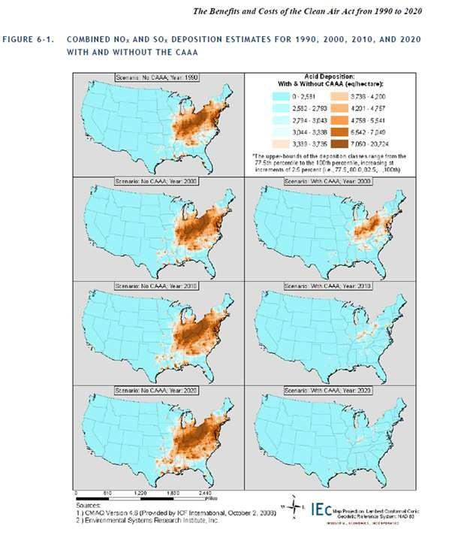

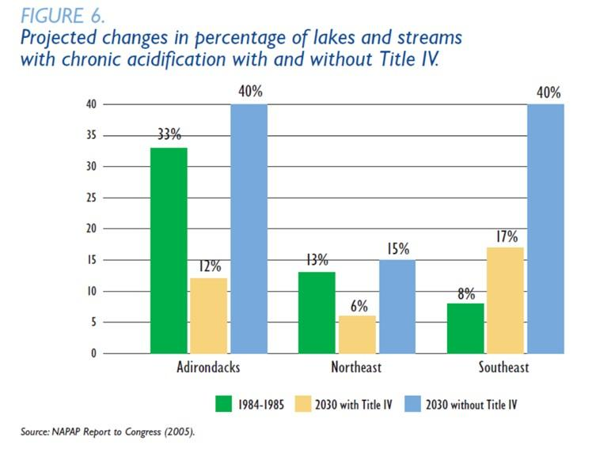

Figure 2: Comparing acidification of lakes and streams with and without CAT (2010)**xiii**

**Concern Over Hotspots**

Upon first examination, it would appear quite evidently that CAT’s success buttresses the position that economic, free-market solutions led to unbridled success. Examining the literature behind the matter, however, shows us that there is still some debate about the topic. Specifically, there are concerns that CAT may have led to the development of unforeseen externalities, as CAT placed no regional or temporal controls on the trading market. SO2 is a highly regional pollutant, predominantly affecting those in the immediate vicinity of the pollution site. While the aimed-for level of aggregate national emissions may reach the desired level, there may still be dangerous concentrations of pollution in specific areas. Concentrations of SO2 at harmful levels may well arise as the result of trading and banking. While it may be cost-effective for firms in the west to sell a large proportion of their permits to eastern counterparts, this may still have dire consequences. In this example, inhabitants of the surrounding area of the eastern power plants, however, may be exposed to a much higher level of pollution than their western counterparts, who are exposed to much lower concentrations. It seems reasonable to hypothesize that this could lead to economic costs in the east that exceed the benefits accrued. While it may remain true that net national economic benefits of CAT may be positive, very real negative effects may be felt by the inhabitants of a region in which pollution increases as a result of the trading of permits.

The fact that permits can be banked indefinitely may also cause similar damage. As of yet it seems that firms were generally over-complying, and were banking a large proportion of their permits in anticipation of future need or unforeseen events. Should this trend continue, it may well come to pass that future emissions could be significantly over the capped amount. This was already shown to be the case during the first few years of stage 2. As a result, firms may emit SO2 at considerably high levels, given the temporal nature of banking. This would lead to a lack of pollutant symmetry similar to the geographic concern, though of a temporal nature. Before we so whole-heartedly accept CAT as a uniformly unambiguous success, these concerns must be addressed.

The CAT program was an amendment to previous legislation governing such emissions, and as such plants must continue to abide by local standards as well. It should still, however, be highly informative to establish which states and counties, if any, experienced an increase in SO2 emissions in either stage 1 or stage 2, relative to stage 0, as states and counties can often be outside of attainment, purposefully or unpurposefully obfuscate attempts at measurement and regulation, and cause aggregate state or county level effects of SO2 emissions.

**IV: Data and Methods**

The data that I worked with mainly come from EPA (U.S. Environmental Protection Agency) and EIA (U.S. Energy Information Administration). They are both official open sources and free to download. While I collected panel data for the time periods from 1980 to 2013 in the states, they are not perfectly balanced in time and consecutive due to the lack of full recordings of the observations. Specifically, the data include the years 1980, 1985, 1990, and 1995-2013 (22 years in total). For the states, the data include 47 adjoining U.S. states plus D.C. (Idaho, Alaska, and Hawaii were dropped due to missing data.)

Each observation includes the following data: year; state; SO2emissions (tons), emitted and recorded by coal-burning facilities; Heat Input (mmBtu), a measure of utilization of a given facility, calculated by multiplying the quantity of fuel by the fuel’s heat content; population density of the state (thousand/square mile), which is population divided by area of the state; total energy consumption (billion Btu) in the state; total renewable energy consumption (billion Btu) of the state; and the ratio of renewable energy consumption to total energy consumption.

The dependent variable is ln_SO2, which is the natural log form of SO2 emissions. To measure the impacts of the program, I classified the time periods into three stages: stage 0 (before 1995), which is the base case observation; stage 1 (1995-1999), the first phase of the program implementation; and stage 2 (after 2000), the second phase of the program. Stage 1 and stage 2 are dummy variables (1 for the years in that period) and my main explanatory variables, which I used to reflect the effects of the program’s roll out. I am interested in seeing whether the stage dummies had negative coefficients corresponding to my dependent variable. I also include other independent variables that may affect SO2 emissions, including heat input and total energy consumption, expected to have positive correlations with SO2 emissions, and the renewable energy consumption to total energy consumption ratio, expected to have a negative correlation. I include the control variable of population density of the states as well.

# V: Results and Discussion

**National Level Results**

The actual method of my approach was straightforward. I first ran a fixed effects regression of ln_SO2 on stage 1, stage 2, and the explanatory variables. The regression itself was done to gain a broad view and macro understanding of what the overall, national-level picture looked like. These regressions give results which show whether stage 1 and stage 2 are significantly different from stage 0. In addition to the stage dummies, which are important for the final analysis, I carefully selected other independent variables that may have affected SO2 emissions. I include heat input in order to control for net changes in energy production from 1980 to 2013, that is, to control for the entrance or exit of firms into CAT, as well as the changes in capacity of functioning firms. I also cared about the effect of total energy consumption, population density and the proportion of renewable energy consumption used in total energy consumption.

The variables I used are listed below:

|  |  |  |
| --- | --- | --- |
| Name | Unit | Description |
| lnso2 | Ton | Log form of SO2 emissions, dependent variable |
| Heatinput | MMBtu | Heat input |
| stage1 |  | Stage 1 (1995 to 1999) dummy |
| stage2 |  | Stage 2 (2000 to 2013) dummy |
| Tec | Billion Btu | Total energy consumption |
| Popdens | Thousand/Sqmi. | Population density of each state |
| Rectotec | % | Ratio of renewable energy consumption to total energy consumption |

I first ran separate bivariate regressions for lnSO2 emissions on each independent variable. The results of each regression displayed coefficients which had the expected signs and directions. Further, I made scatterplots of lnSO2 on each of the independent variables to see if a linear relationship was present. The first graph below, which is the scatterplot of lnSO2 on heat input, clearly shows a non-linear relationship. I decided, therefore, to take the natural log form of heat input. The second scatterplot below demonstrates that the linear relationship was applicable for a log-log form.

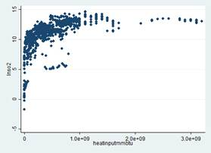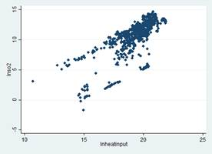

I also took the log form on total energy consumption based on the same reasoning.

The VIF test was used to detect any multicollinearity in my model. Since none of the variables had a VIF score larger than 5, I believe there is no cause for concern over the potential existence of multicollinearity.

. vif

Variable | VIF 1/VIF

-------------+----------------------

lnheatinput | 4.82 0.207347

lntec | 2.90 0.344606

stage2 | 2.10 0.476066

stage1 | 2.08 0.480390

popdens | 2.02 0.494813

rectotec | 1.46 0.682682

-------------+----------------------

Mean VIF | 2.57

I also had some concerns about heteroskedasticity after examining the residual plot. I used the White Test to check this. Based on the results of the White Test, I rejected the null hypothesis and accepted the alternative hypothesis that heteroskedasticity indeed existed with respect to one or more variables. In the final regression, I applied Robust Standard Errors to correct for this. Below are the results of the test.

. whitetst

White's general test statistic : 581.2071 Chi-sq(24) P-value = 2.e-107

Since this is a panel dataset with variables that vary from 1980, 1985, 1990, and 1995-2013, I chose to first run a national-level fixed effects regression of lnSO2 on stage 1, stage 2, log form of heat input, log form of total energy consumption, population density and the ratio of renewable energy consumption to total energy consumption, using Robust Standard Errors.

The regression results show whether Stage 1 and/or Stage 2 were significantly different from Stage 0, which would help determine whether the CAT policy was effective at the national level. The final multivariate regression results at the national level are shown in the following table:

|  |  |  |  |
| --- | --- | --- | --- |
| Variable | Coefficient | p-value | Significant |
| lnheatinput | 0.612 | 0.005 | Yes *** |
| stage1 | -1.113 | 0.000 | Yes *** |
| stage2 | -2.609 | 0.000 | Yes *** |
| lntec | 2.019 | 0.003 | Yes *** |
| popdens | -0.380 | 0.555 | No * |
| rectotec | 2.056 | 0.139 | No * |

The results of the national-level fixed effects regression are clear. Most importantly, coefficients of both stage 1 and stage 2 are negative and significantly different from stage 0, which means the program was indeed effective in reducing SO2 emissions in both stages. It is also important to note that the p-values are almost zero, implying that both stages are significantly different from stage 0, even at the 0.01 level.

Population density and the ratio of renewable energy consumption to total energy consumption, which I believed would have affected SO2 emissions, are surprisingly not significant in this regression. I therefore decided to drop the two insignificant variables and subsequently ran another regression, the results of which are below.

|  |  |  |  |
| --- | --- | --- | --- |
| Variable | Coefficient | p-value | Significant |
| lnheatinput | 0.597 | 0.004 | Yes *** |
| stage1 | -1.142 | 0.000 | Yes *** |
| stage2 | -2.581 | 0.000 | Yes *** |
| lntec | 2.112 | 0.002 | Yes *** |

Coefficients of both stage 1 and stage 2 are still negative and significantly different from stage 0 at the 0.01 level. Comparing the absolute value of the two coefficients, we can see that the policy is more effective from stage 1 to stage 2. Two other variables, “lnheatinput” and “lntec” are also significant and have positive correlations with lnSO2, as expected.

The overall results confirm that, at the national level, the program indeed reduced SO2 emissions significantly during stage 1, and that the reduction was even more pronounced when comparing stage 2 to stage 0. The same variables will be used later in a state level analysis.

I also ran an alternative national level analysis by including another variable “teap”, which was total energy average prices, to determine its correlation with SO2 emissions. The results of this are below.

|  |  |  |  |
| --- | --- | --- | --- |
| Variable | Coefficient | p-value | Significant |
| lnheatinput | 0.667 | 0.002 | Yes *** |
| stage1 | -0.981 | 0.002 | Yes *** |
| stage2 | -1.433 | 0.022 | Yes ** |
| lntec | 1.819 | 0.005 | Yes *** |
| teap | -0.077 | 0.028 | Yes ** |

In this alternative regression I find that the coefficient of stage 1 is still negative and significantly different from stage 0 at the 0.01 level, as was found previously. The stage 2 dummy, however, is only negative and significant at the 0.05 level. Two other variables, “lnheatinput” and “lntec,” are also significant at the 0.01 level and have positive correlations with lnSO2. The new variable “teap”, total energy average prices, has a negative correlation with SO2 emissions and is significant at the 0.05 level.

# State Level Results

In addition to the national level analysis, I am also interested in the effectiveness of the policy at the state level. Since firms could trade pollution permits under the CAT scheme, emissions within specific states may have increased during a certain period because no geographic bounds were placed on the trade. Therefore, it makes sense to check the state level data to see if “hotspots” existed during the two stages.

I ran 48 state-level (47 states plus DC) regressions with the four independent variables (two stage dummies, lnheatinput and lntec) from the final national level regression. Observing the coefficients of stage 1 and stage 2 in each regression, I find that they are significantly negative in some states, implying a successful implementation of the policy, while in other states stage dummies have significantly positive coefficients, indicating concern over possible hotspots. See Appendix 1 for detailed state-level results.

The following table is a summary of the state level analysis. All coefficients were significant at the 0.05 level.

|  |  |  |
| --- | --- | --- |
| Stage | States - Negative | States – Positive |
| Stage 1 | 19 states | CO, LA, NV, OK, UT |
| Stage 2 | 27 states | CO, LA, NE |

In stage 1, there were 19 states with significantly negative coefficients of the stage dummy and 5 states with significantly positive coefficients. In stage 2, 27 states had negative coefficients and only 3 states had positive ones.

States with negative stage dummy coefficients far outnumber states with a positive stage dummy, in both stages. I also found out that in stage 2, more states saw a reduction in SO2 emissions and the hotspot issue was also less severe in comparison with stage 1, which once again confirmed the success of the policy implementation.

After examining the results of 48 state level regressions, I found that the state level analysis is not as robust statistically as the national level analysis. As such, the conclusions can be drawn somewhat into question. However, they are a good first step towards further research in which different independent variables at the state level could be analyzed.

In sum, at the national level, it was found that both stage 1 and stage 2 are significantly and negatively different from stage 0. In terms of the reduction of SO2 emissions, stage 2 was more negatively different from stage 0 than stage 1 was. I can conclude that at the national level, the program worked well in reducing overall SO2 emissions over the defined two periods.

At the state level, the number of states which experienced a significant decrease of SO2 emissions during stage 1, as compared to stage 0, was high. Further, more states had reduction in SO2 emissions when comparing the negative coefficient results of stage 1 and stage 2. Hotspots, however, were also found. Specifically, five states in stage 1 and three states in stage 2 were found to have positive coefficients. Among these states, Colorado and Louisiana experienced an increase in SO2 emissions in both stages, which may deserve further study. All in all, given the state level results, I can conclude that hotspots did indeed occur in some states. While they slightly decreased between stage 1 and stage 2, they did not disappear completely. While these hotspots can be seen as a concern, I believe that they generally pale in comparison to the overall reduction in SO2 emissions the program was responsible for at both the national and state levels.

Future environmental policy makers can refer to the results of this analysis when they are considering the impact of a policy at national, state and even municipal levels.

# VI: Conclusion

In brief, these findings are interesting. At the national-level, for the analysis that utilized the state-level data, it was found that both stage 1 and stage 2 are significantly and negatively different from stage 0. Further, it is apparent that, given the corresponding p-values of the coefficients, stage 2 was more negatively different, in terms of emissions, than stage 1. All of this points to the fact that, at the national level, the program worked well in reducing overall SO2 emissions over the two phases defined.

Secondly, the number of states which experienced a significant diminishment of SO2 emissions during stage 1, as compared to stage 0, were high. Further, the number of states with drops in emissions increased even more when comparing the negative coefficient returns of stage 1 and stage 2. There were, however, states for which the level of SO2 emitted was higher during stage 1 than that of stage 0. Specifically, the states with increased SO2 emissions during stage 1 included (at the 0.05 p-value), CO, LA, NV, OK, and UT. Other states also experienced an increase at stage 2 (at the 0.05 p-value), and included CO, LA, and NE.

In sum, I can infer that the program was found to be, generally, a successful one when considering national-level emissions. This is intuitive, as the primary goal of the cap-and-trade program itself was to diminish aggregate, national-level SO2 emissions to 50% of 1980 levels. No geographic bounds were placed on the trade of the permits, however, which generally led to the concern over hotspots which I have attempted to address in this paper. Through my analyses, I found that hotspots did indeed occur. Specifically, CO, LA, NV, OK, and UT all experienced a significant increase in emissions during the period 1995 to 1999. For the period 2000 to 2013, CO, LA, and NE experienced an increase in emissions relative to stage 0 levels, with a great many states experiencing a decrease in state-level emissions during this same period. All in all, given the state results, it can be said that hotspots did indeed occur in the areas listed, but these hotspots either disappeared completely between stage 1 and stage 2, or diminished quite a bit. While these hotspots can be construed as a concern, it is important to note that they generally pale in comparison to the reduction in SO2 emissions the program has been responsible for.

**VII: Bibliography**

Burtraw, Dallas and Mansure, Erin (1999), *The Effects of Trading and Banking in the SO2 Allowance Market*

(Resources for the Future, Washington D.C.).,

Burtraw, Dallas and Palmer, Karen (2003), *The Paparazzi Take a Look at a Living Legend: The SO2 Cap-and-Trade Program for Power Plants in the United States* (Resources for the Future, Washington D.C.)

Cramton, Peter (2000), “A Review of Markets for Clean Air: The U.S. Acid Rain Program”, *Journal of Economic Literature* 38(3):627-633

US EPA, Benefits and Costs of the CAA, 1990-2020 (March 2011), p.6-13

US EPA, “Acid Rain Program Benefits Exceed Expectations,” 2010, p.4 (citing Lauraine G. Chestnut and David M. Mills, “A Fresh Look at the Benefits and Cost of the US Acid Rain Program,” Journal of Environmental Management, Vol. 77, Issue 3 (November 2005), 252-266.)

**VIII: Appendix**

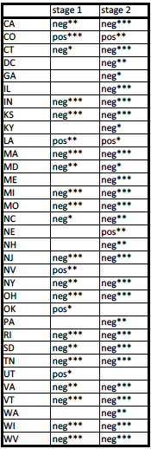

Appendix 1: State level results

i Burtraw, Dallas and Palmer, Karen (2003), *The Paparazzi Take a Look at a Living Legend: The SO2 Cap-and-Trade Program for Power Plants in the United States* (Resources for the Future, Washington D.C.), page 2

ii Cramton, Peter (2000), “A Review of Markets for Clean Air: The U.S. Acid Rain Program”, *Journal of Economic Literature* 38(3):627-633, page 627

iii Cramton, Peter (2000), “A Review of Markets for Clean Air: The U.S. Acid Rain Program”, *Journal of Economic Literature* 38(3):627-633, page 627

iv Burtraw, Dallas and Palmer, Karen (2003), *The Paparazzi Take a Look at a Living Legend: The SO2 Cap-and-Trade Program for Power Plants in the United States* (Resources for the Future, Washington D.C.), page 5

v ibid page 5

vi Cramton, Peter (2000), “A Review of Markets for Clean Air: The U.S. Acid Rain Program”, *Journal of Economic Literature* 38(3):627-633, page 630

vii Ibid, page 629

viii Burtraw, Dallas and Palmer, Karen (2003), *The Paparazzi Take a Look at a Living Legend: The SO2 Cap-and-Trade Program for Power Plants in the United States* (Resources for the Future, Washington D.C.), page 18

ix Ibid, page 7

x Ibid, page 7

xi Ibid, page 8

xii US EPA, Benefits and Costs of the CAA, 1990-2020 (March 2011), p.6-13

xiii US EPA, “Acid Rain Program Benefits Exceed Expectations,” 2010, p.4 (citing Lauraine G. Chestnut and David M. Mills, “A Fresh Look at the Benefits and Cost of the US Acid Rain Program,” Journal of Environmental Management, Vol. 77, Issue 3 (November 2005), 252-266.)

xiv Burtraw, Dallas and Mansure, Erin (1999), *The Effects of Trading and Banking in the SO2 Allowance Market*

(Resources for the Future, Washington D.C.)., page 13

xv Ibid, page 11

xvi <http://camddataandmaps.epa.gov/gdm/index.cfm?fuseaction=emissions.wizard>